Allah has ordered us not only to preform our mandatory Ibadah, but to also treat our dear parents with the ultimate compassion. The best way to understand this important concept is to put ourselves in the shoes of our parents by asking ourselves how we would you want our children to treat you in the future? ____________________________________________In the future your children will treat you the same way you treat your parents.
The first basic right of parents is obedience. You must listen to any orders or requests given by your mother of father. After all, they care about your well-being ever since you were born. The one and only case in which one does not listen to his or her parents, is if they order you to do something that is Haram (impermissible in Islam).
The second right of parents is respect. In the Quran Allah (SWT) said:
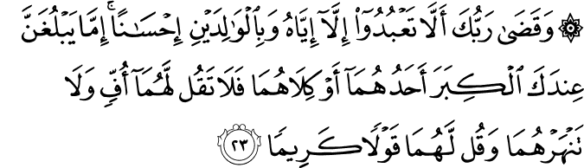
Sahih International
And your Lord has decreed that you not worship except Him, and to parents, good treatment. Whether one or both of them reach old age [while] with you, say not to them [so much as], "uff," and do not repel them but speak to them a noble word.

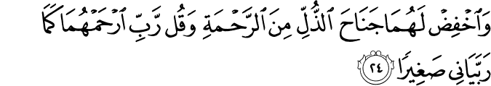
Sahih International
And lower to them the wing of humility out of mercy and say, "My Lord, have mercy upon them as they brought me up [when I was] small."

This ayah explicitly demonstrates the magnitude and severity of this issue. The first part of the ayah shows the importance and status of parents, by first mentioning the highest status of Allah (SWT), and then immediately following with the parents. The ayah then continues on to talk about the humility and humbleness we should have towards them. This all falls under the umbrella of respect and is the backbone of our relationship with them.
Lastly, when we grow to an age of maturity and independence, we must provide both physically and financially for both our parents. If our parents get sick, or are too weak to be independent, we must care for them. We should not forget the sleepless nights our mothers faced and the long, endless hours are fathers worked, all with the intention of pleasing Allah (SWT) by providing us with the best possible living conditions.
This is exactly why disobedience, rudeness, defiance, and a lack of care and respect towards parents are major sins, considering what they went through and endured for us.
At the end, if we believe in Allah (SWT) and follow his commandments by listening to our parents, Allah (SWT) will enter us into Jannah, where we will forever be happy and worry- free.

Assalam Alikum ---------------DUA

